**Classification**

**Q12005 Vs Q22005**

1. **Logistic Regression**

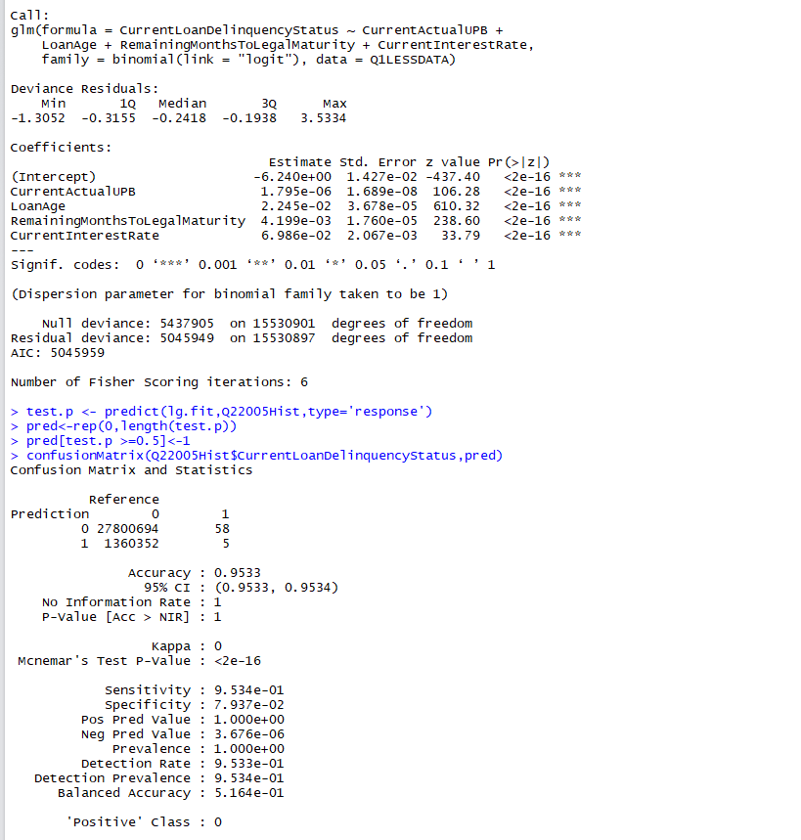

***ROC Curve***

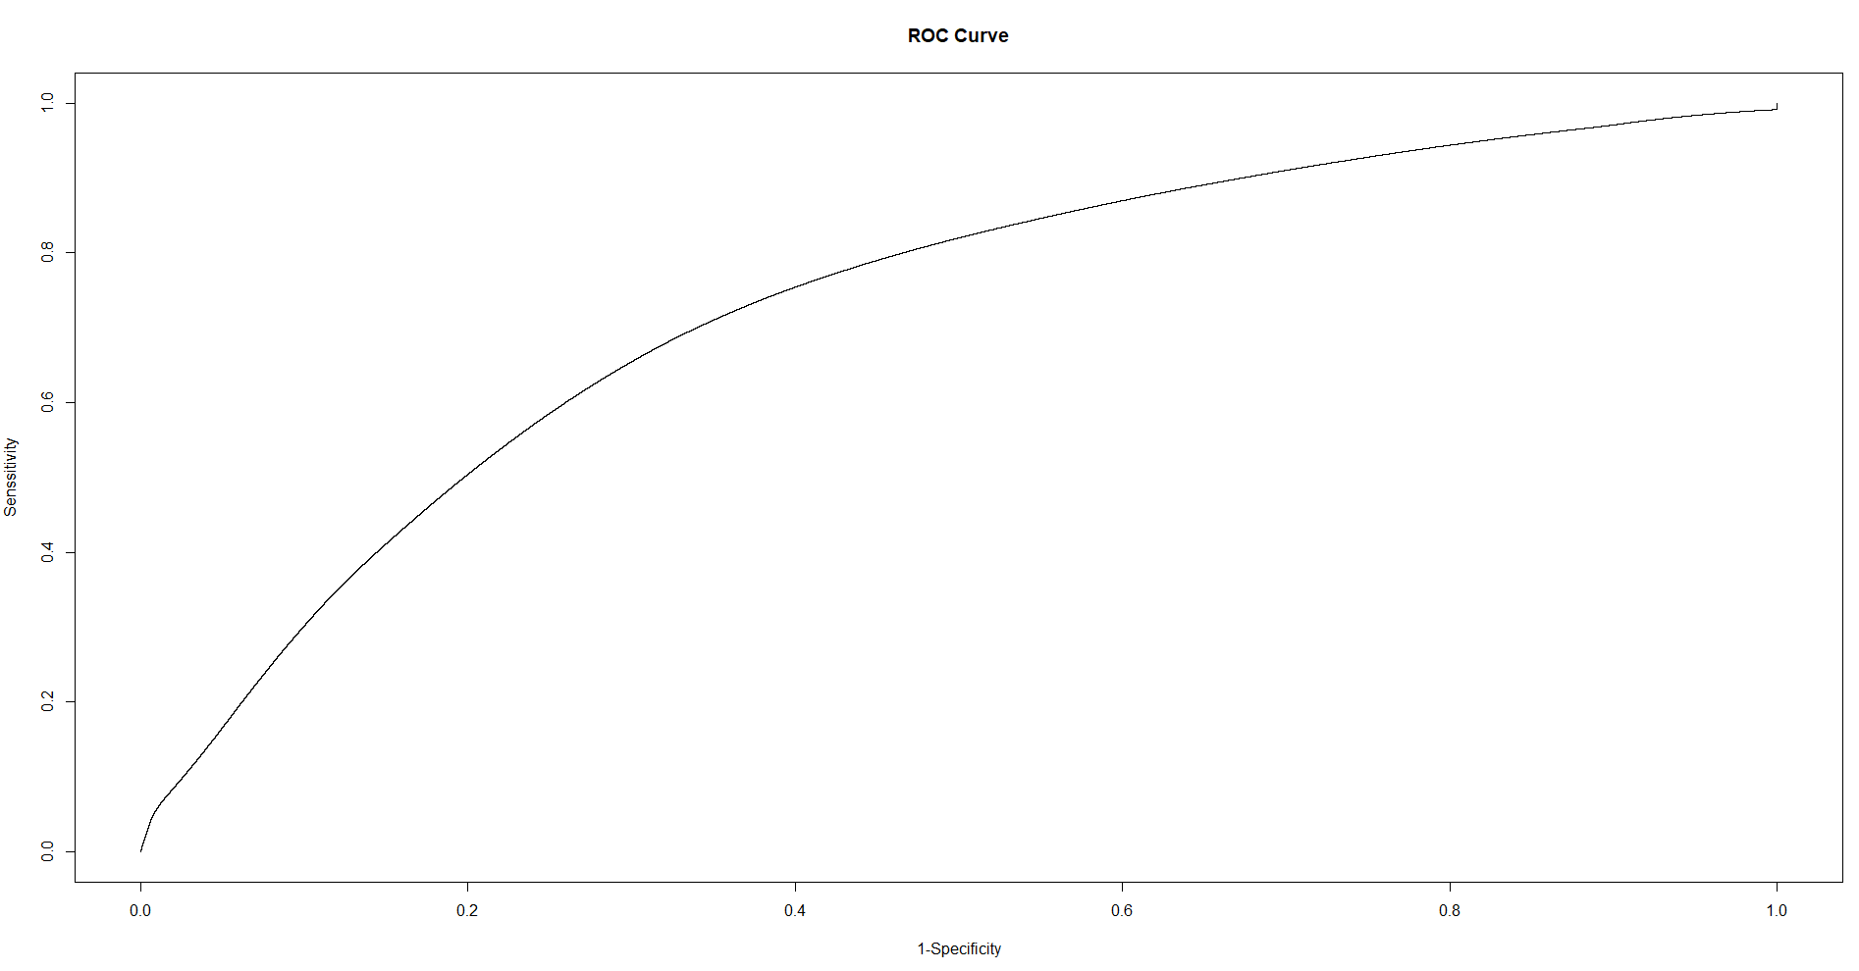

1. **Random Forest**

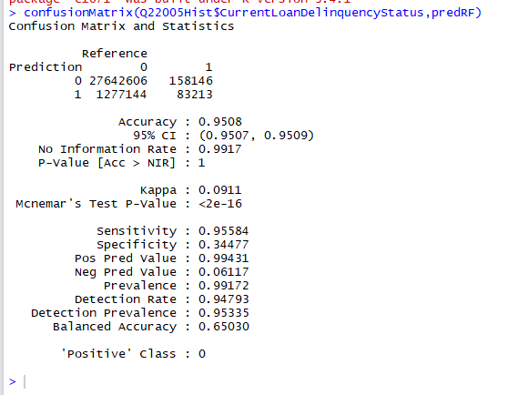

***ROC Curve***

